PRINTS-EUR-Italy-Rome-Tiber Island-Patouillard-d'Espouy-1900

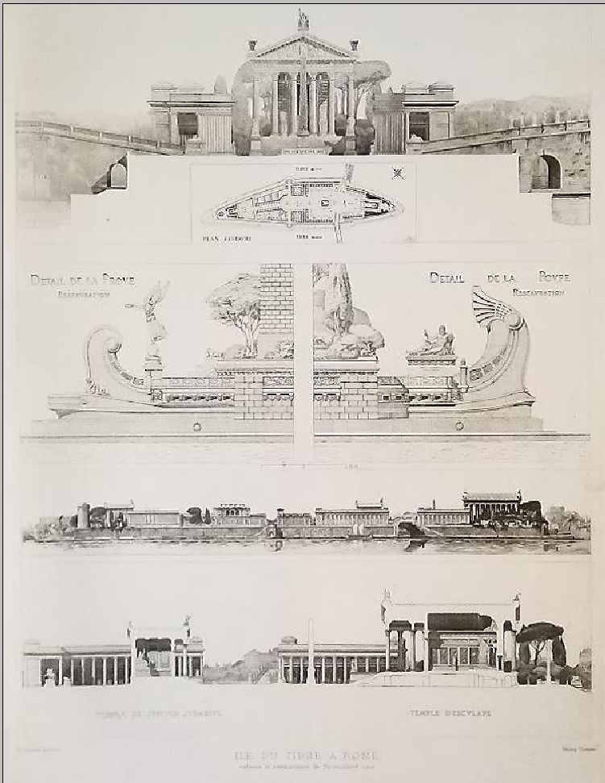

TIBER ISLAND AT ROME based on the 1900 restoration by Patouillard

**Print Specifics:**

* **Type of print:** Heliogravure - Original French antique print.
* **Year of printing:** not indicated in the print - actual 1905
* **Publisher:** H. d' Espouy, Charles Schmid, Editeur, Paris
* **Condition: 1**(1. Excellent - 2. Very good - 3. Good - 4. Fair).
* **Dimensions:** 11.5 x 16.5 inches (29 x 42 cm), including blank margins (borders) around the image.
* **Paper weight: 1-2**(1. Thick - 2. Heavier - 3. Medium heavy - 4. Slightly heavier - 5. Thin)
* **Reverse side:**Blank
* **Notes:**  (1) Green color around the print in the photo is a contrasting background on which the print was photographed; (2) The slightly uneven tone in the photos was caused by the light coming from one side only. (3) The print will be mailed rolled in a 4" (10 cm) diameter sturdy tube.

**Narrative:**   
  
Under the direction of Prof. d'Espouy, the graduates of the famous Paris school of art, the Ecole des Beaux-Arts, measured, rendered and shaded the views of the famous monuments of ancient Greece and Rome. These drawing were then reproduced by a 19th C. process called heliography.

**Narcisse Théophile Patouillard** (2 July 1854 – 30 March 1926) was a French [pharmacist](https://en.wikipedia.org/wiki/Pharmacist) and [mycologist](https://en.wikipedia.org/wiki/Mycologist).

He was born in [Macornay](https://en.wikipedia.org/wiki/Macornay" \o "Macornay), a town in the department of [Jura](https://en.wikipedia.org/wiki/Jura_(department)). He studied in [Besançon](https://en.wikipedia.org/wiki/Besan%C3%A7on" \o "Besançon), then furthered his education at the École Supérieure de Pharmacie in [Paris](https://en.wikipedia.org/wiki/Paris), where in 1884 he earned a diploma with a doctoral thesis involving the structure and classification of [Hymenomycetes](https://en.wikipedia.org/wiki/Hymenomycetes" \o "Hymenomycetes) called "*Des Hyménomycètes au point de vue de leur structure et de leur classification*".[[1]](https://en.wikipedia.org/wiki/Narcisse_Th%C3%A9ophile_Patouillard#cite_note-1)

Patouillard was a practicing pharmacist for more than forty years, first in [Poligny](https://en.wikipedia.org/wiki/Poligny,_Jura" \o "Poligny, Jura) (1881–84), and later in [Fontenay-sous-Bois](https://en.wikipedia.org/wiki/Fontenay-sous-Bois) (1884–85), Paris (1886–1898) and [Neuilly-sur-Seine](https://en.wikipedia.org/wiki/Neuilly-sur-Seine) (beginning in 1898). From 1893 to 1900, he was *préparateur* to the chair of [cryptogamy](https://en.wikipedia.org/wiki/Cryptogam" \o "Cryptogam) at the École Supérieure de Pharmacie in Paris. In 1884 he was one of the founders of the [Société mycologique de France](https://en.wikipedia.org/wiki/Soci%C3%A9t%C3%A9_mycologique_de_France" \o "Société mycologique de France) and served as its third president in 1891-92. In 1920 he became an honorary member of the [British Mycological Society](https://en.wikipedia.org/wiki/British_Mycological_Society). He died in [Paris](https://en.wikipedia.org/wiki/Paris), aged 71.

Patouillard is highly regarded for his taxonomical work in mycology, and during his career, he described numerous genera and species of [fungi](https://en.wikipedia.org/wiki/Fungi). The following are some of the genera that he is the [taxonomic authority](https://en.wikipedia.org/wiki/Binomial_authority) of: [*Guepiniopsis*](https://en.wikipedia.org/wiki/Guepiniopsis), [*Hirsutella*](https://en.wikipedia.org/wiki/Hirsutella), [*Lacrymaria*](https://en.wikipedia.org/wiki/Lacrymaria_(fungus)), [*Leucocoprinus*](https://en.wikipedia.org/wiki/Leucocoprinus), [*Melanoleuca*](https://en.wikipedia.org/wiki/Melanoleuca) and [*Spongipellis*](https://en.wikipedia.org/wiki/Spongipellis). A mycological species called *[Inocybe patouillardii](https://en.wikipedia.org/wiki/Inocybe_erubescens" \o "Inocybe erubescens)* (brick-red tear mushroom) is one of the species named after him.

He was the author of nearly 250 works, and was a leading authority on tropical mycology. Over 100 of his publications involved studies of fungi from diverse locales such as [Brazil](https://en.wikipedia.org/wiki/Brazil), [Java](https://en.wikipedia.org/wiki/Java), [Guadeloupe](https://en.wikipedia.org/wiki/Guadeloupe), [Mexico](https://en.wikipedia.org/wiki/Mexico), [New Caledonia](https://en.wikipedia.org/wiki/New_Caledonia), the [Gambier Islands](https://en.wikipedia.org/wiki/Gambier_Islands), [Philippines](https://en.wikipedia.org/wiki/Philippines), et al.

Selected writings[[edit](https://en.wikipedia.org/w/index.php?title=Narcisse_Th%C3%A9ophile_Patouillard&action=edit&section=1" \o "Edit section: Selected writings)]

* *Tabulae analyticae Fungorum* (Analytic tables of fungi), 1883–1889.
* *Les Hyménomycètes d'Europe. Anatomie générale et classification des champignons supérieurs* (The Hymenomycetes of Europe. General anatomy and classification of the higher fungi) 166 pp. 1887.
* *Fragments mycologiques: Notes sur quelques champignons de la Martinique*(Notes on certain mushrooms of [Martinique](https://en.wikipedia.org/wiki/Martinique)) in Journal of Botany 3 pp. 335 - 343, 1889.
* *Essai taxonomique sur les familles et les genres des Hyménomycètes*
* 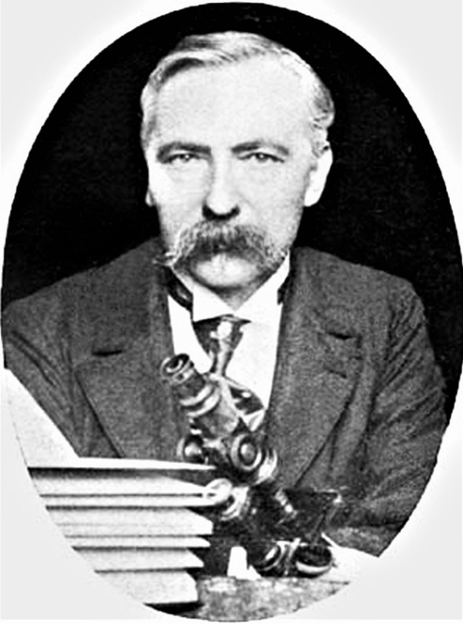
* Narcisse Theophile Patouillard (1854-1926) photographie prise par William Ashbrook Kellerman, publiée en 1906 dans *Ohio Mycological Bulletin*

The drawings submitted for the annual Grand Prix de Rome were on themes chosen by the Academy. The subjects set are indeed grand in scale and often in reach: triumphal arches (1730, 1747, 1763), palaces (1752, 1772, 1791, 1804, 1806), city squares and markets (1733, 1792, 1801), town halls (1742, 1787, 1813), law courts (1782, 1821) museums (1779) and educational institutions including libraries (1775, 1786, 1789, 1800, 1807, 1811, 1814, 1815, 1820) - all schemes for the promotion of civilization as the ancients would have understood the term. Stylistically, the entries usually share common characteristics: a grand Roman manner, with columns and orders, vaults and polychromy; an insistent and regular geometry, usually the square or the circle but sometimes the triangle; a penchant for the hemicycle, the propylaea and the pyramid; and finally a desire to impress by symmetry and the contrast between plain and decorated surfaces.

These ground plans (a drawing projected on a horizontal plane) and elevations (which was projected on a vertical plane) first were shown in Rome at the French Academy and then were forwarded to Paris to be shown to the members of the Academie des Beaux Arts, one of the constituent bodies of the Institut de France, which was responsible for the Rome Academy. They were also exhibited to the public in Paris. In the fourth year, after a thorough study of architectural detail, the student presented a complete restoration of a classical building. Although drawings of ancient classical ornament had been made for generations before the winners of the Grand Prix de Rome descended on the Villa Medici, the young Frenchmen were the first to go about the work systematically. The drawings were limited to, and solidly based on, the carefully studied remains. Further, their presentation in formal academic renderings offers more information than could possibly be supplied even by a large number of photographs.

Appreciation of these drawings cannot be complete without some explanation of the technique of India Ink was rendering. Extreme discipline is required to produce these finely studied works of art. Even the simplest drawings require painstaking care and preparation before any of the washes are applied. Great skill is required to do the neccesary linework. All of the information must be recorded before tone is even thought about. The drawing is then meticulously transferred in ink to the watercolor paper and the paper mounted on a board. The rendering itself requires infinite care and patience. Each tone is built up through many faint layers of wash so that the ink seems to be in the paper rather than on it. Each surface is graded so that the final effect of the drawing is that of an object in light and space, with a sense of atmosphere surrounding it.

|  |  |
| --- | --- |
| **Item price** | $50.00 |